**CAPSTONE PROJECT REPORT**

(Project Term January-April, 2021)

# Pulse Detection using webcam

Submitted by

**Padma nabha sai kiran Registration Number :11704899**

**Vangala Sujith reddy Registration Number :11710317**

**Course Code: CSE445**

Under the Guidance of

**(Mr. Mamoon Rashid: 20574)**

# 

School of Computer Science and Engineering

**DECLARATION**

We hereby declare that the project work entitled (“Pulse Detection Using Web Cam”) is an authentic record of our own work carried out as requirements of Capstone Project for the award of B. Tech degree in Computer Science & Engineering from Lovely Professional University, Phagwara, under the guidance of Mr. Mamoon Rashid, during January to May 2020. All the information furnished in this capstone project report is based on our own intensive work and is genuine.

Name of Student 1: Padma Nabha sai kiran

Registration Number: 11704899

Name of Student 2: Vangala Sujith reddy

Registration Number: 11710317

(Signature of Student 1)

Date:

(Signature of Student 2)

Date:

# CERTIFICATE

This is to certify that the declaration statement made by this group of students is correct to the best of my knowledge and belief. They have completed this Capstone Project under my guidance and supervision. The present work is the result of their original investigation, effort and study. No part of the work has ever been submitted for any other degree at any University. The Capstone Project is fit for the submission and partial fulfilment of the conditions for the award of B. Tech degree in Computer Science Engineering (CSE) from Lovely Professional University, Phagwara.

**Mr. Mamoon Rashid**

School of Computer Science and Engineering,

Lovely Professional University, Phagwara, Punjab.

Date:

## **ACKNOWLEDGEMENT**

I/We would like to express our deepest appreciation to all those who provided us the possibility to complete this report. A special gratitude we give to our subject mentor, **Mr. Mamoon Rashid**, whose contribution in stimulating suggestions and encouragement,helped us to coordinate our project especially in writing this report and enhancing our idea of project and initiating it.

Furthermore, we would also like to acknowledge with much appreciation the crucial role of our parents, who provided all required and necessary materials and support to complete this project of “**Heartrate Monitor System: Using Webcam”**.

We have to appreciate the guidance given by other supervisor as well as the panels especially in our project presentation that has improved our presentation skills thanks to their comment and advices.

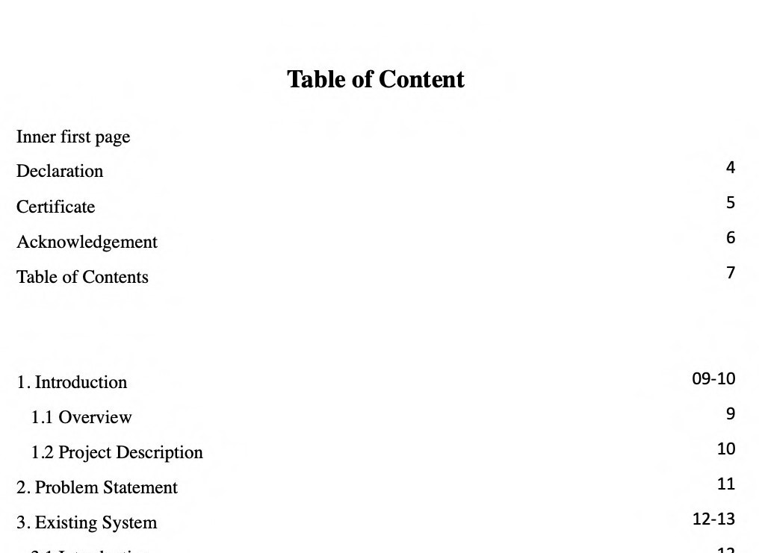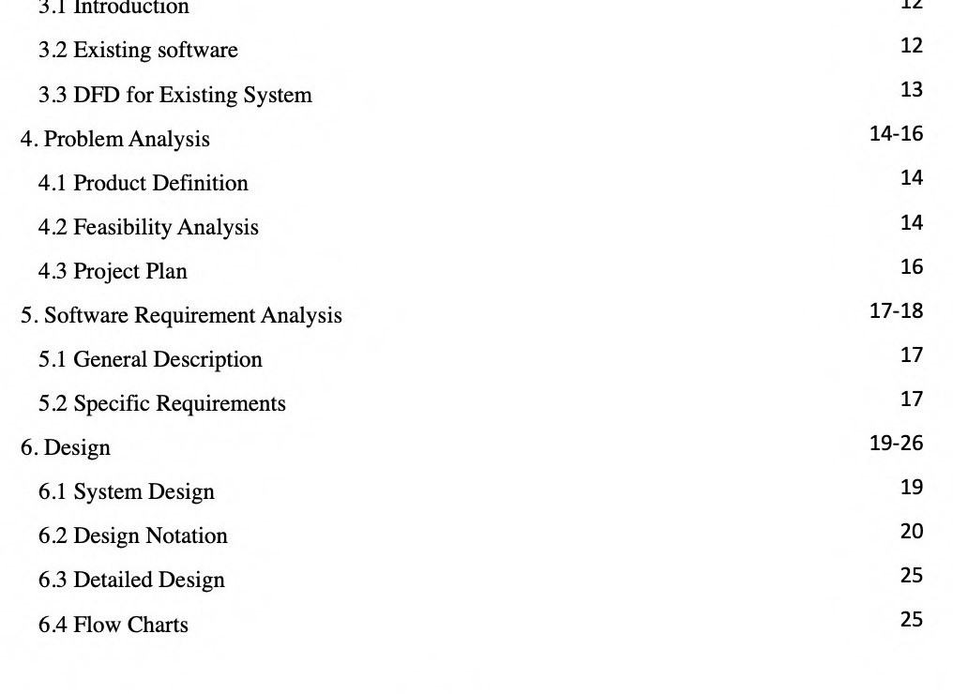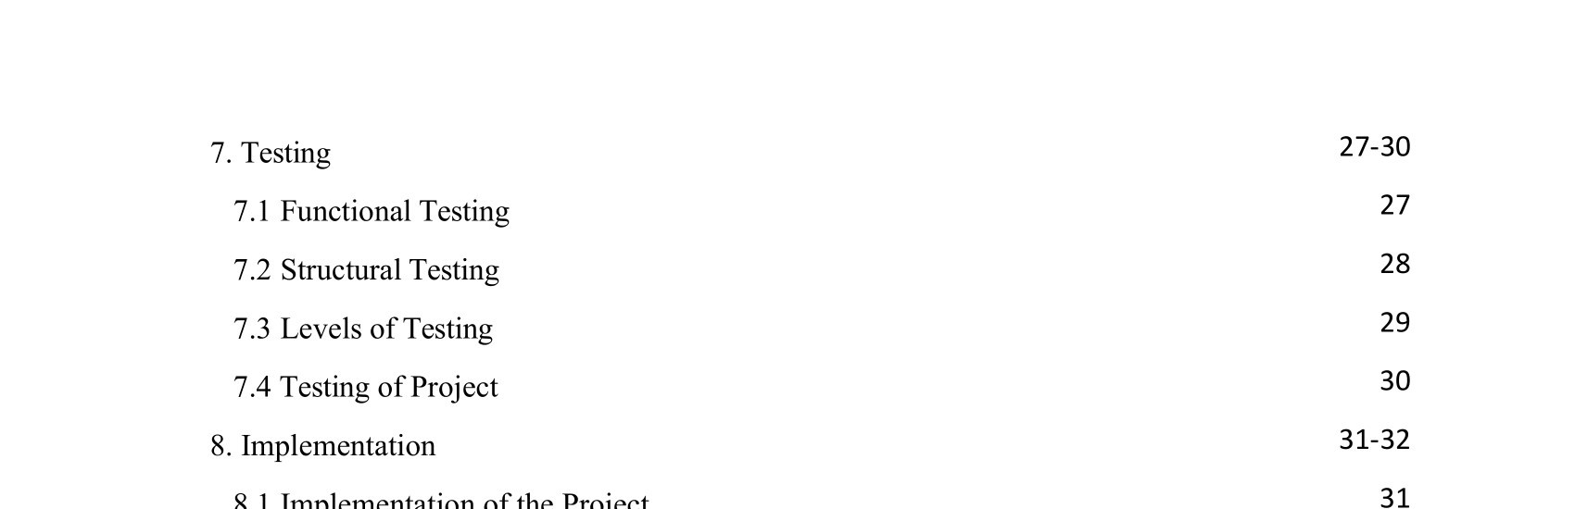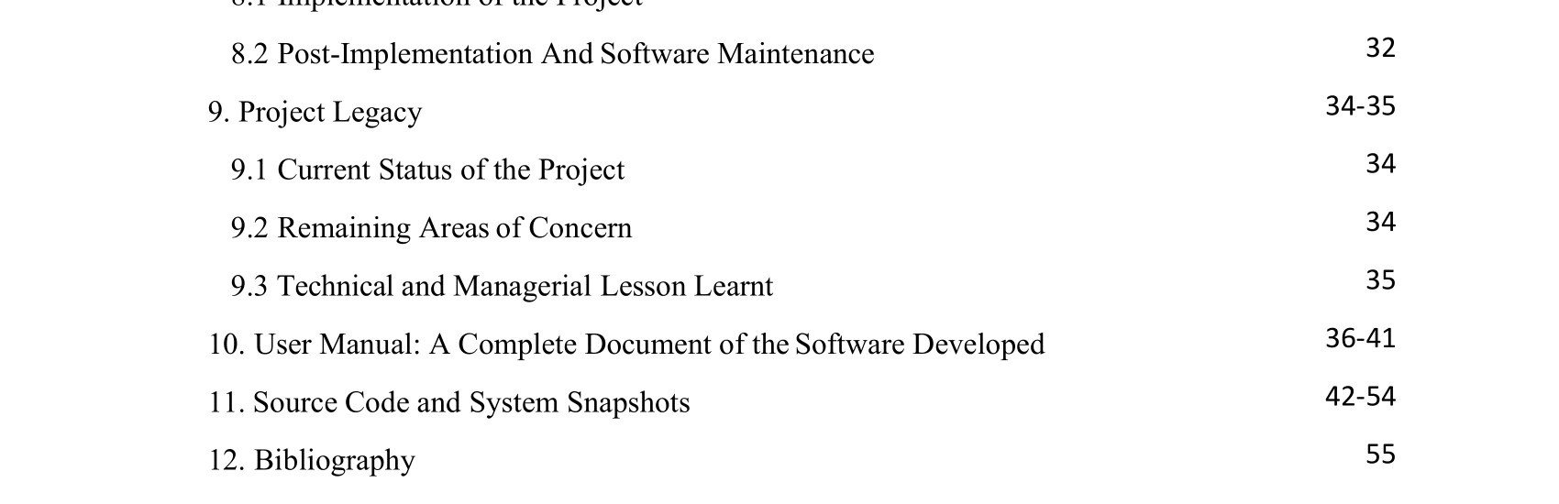

CHAPTER 1

INTRODUCTION

## Overview

In this current crisis of COVID 19 pulse detection is at most important stage. This Project majorly focuses on pulse detection and its application in most commonly used electronical devices

1. Web cam pulse detector: It focuses on pre-frontal lobe (i. e. forehead region) to measure the optical intensity which is responsible for pulse measurement. It uses OpenCV for face detection and python for programming/coding.

## Project Description

Due to the current COVID19 crisis the numbers of patients have increased as compared to limited seats availability in hospitals. So, the importance of home health monitoring system has increased as this epidemic is very dangerous. Due to the symptoms like low pulse rate and difficulty in breathing the measuring of pulse rate has become of upmost importance. In this research paper the Web cam pulse detector and Arduino implementation is thoroughly studied. The pulse detector uses web cam of personal computer for image processing and calculating heartrate/ heartbeat in (BPM) at home. The heartbeat is measured depending on various factors like PPG (Photoplethysmography) an optical technique implemented using dedicated light sources like LED (Light emitting diode) and IR (Infrared) rays depending of color transformation and specific wavelengths the blood oxygen saturation and blood volume pulse (BVM) is detected by recording human face using OpenCV and fingertip to obtain the pulse rate of non-contact surface (i.e. heart) by proper image processing. The fitness level of a person is determined by BPM which is (100-160) for Babies and (60-100) for Adults it varies between children and athletes. It's costless and a novel methodology for calculating pulse rate for cardiovascular and COVID19 patients at home. It records the undergoing different intensities to measure assessments on basis of physiological conditions of a person. As Lightheadedness, Chest pain, Dizziness, low breathing is determined.

CHAPTER 2

THE PROBLEM STATEMENT

The main scope of this project is to provide assistance to the people where they can check their pulse rate at their convenience. This set up has capability to measure the heart rate of the person using smart phone or using the desktop application, to make it more accurate we can even use the set up designed using Arduino uno. It basically needs more efforts and time to reach a doctor every time to do regular checkup regarding pulse rate. It even needs some pennies to afford. Here we designed the system which can work on basic gadgets like mobile and computer system. Application once installed on mobile can be used anywhere to get pulse rate of a person at their own convenience, so that they can’t restrict themselves from taking care of their health. Those who have accessibility of computer can also use this application to get the heart rate. This project is going to help all those who can’t afford money for regular checkups and those who can’t afford their time for all these tiny things.

## 2.2 Solution of The Problem

This project is basically designed to calculate the heart rate of a person using their finger or forehead. We designed three system software which can be used by the user as wherever and whenever they want. While using mobile application, user uses finger to get his/her pulse rate where as he/she uses forehead to get pulse rate while using the web application. These are designed in way that these can capture the user pulse within few seconds to provide the results. User can export these data into csv file while using the web application for further researches. This is not age restricted and can be used by anyone who are familiar with using mobile or computer

CHAPTER 3

EXISTING SYSTEMS

## 3.1 Introduction

The concept of web cam pulse detector using webcam, Arduino uno and mobile application has taken to provide the utmost assistance to the people for their wellness by letting them check their heart rate regularly. Basically, it needs money, time and efforts to visit a doctor every time. Here we are with our application to provide more accurate result which can be used anywhere and everywhere in this world.

3.2 What’s the new in the system to be developed?

Yes, this is not a new technology, this is before used in thermal gun to check the temperature of a person, we took inspiration from that and we tried to implement the same technology to find the heart rate of a person with more accurate results when compared to others. Others need experience and specialization to use those gadgets whereas these applications can even be used by kids and elderly people without any prior knowledge. It just need a forehead to detect the heart rate while using web application where as we can use our fingers to retrieve heart rate while using mobile application. Users can export their data in the form of CSV files which isn’t available in many other systems.

## 3.3 DFD for Present System

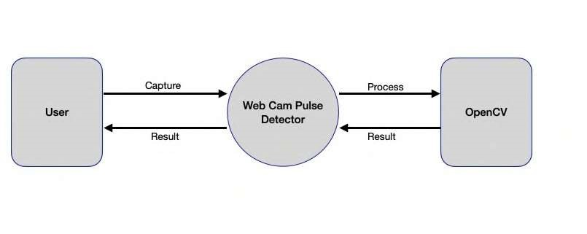

Figure 1: 0 Level DFD for Webcam Pulse detector system

CHAPTER 4

PROBLEM ANALYSIS

## 4.1 Product Definition

Our Product Heart Rate Monitor System: Using Webcam, Android is easy to use, all you need to visit the interface there you need to select the option named as open camera. Once user click on the camera button the application will access the web cam. Now it detects the forehead of a person which will be further processed by the machine learning tool OpenCV. Once the process is completing you can see the result displayed with accuracy on the screen. The user can exit at any time from the application.

Features of product includes:

* It can recognize the Forehead.

* The interface is easy to understand which makes it simple to deal with.

## 4.2 Feasibility Analysis

This framework is practical through all the perspectives including specialized plausibility, monetary achievability, authoritative attainability and so forth This GUI is perhaps the best interface as per client perspectives and desires. It is savvy, creative, exact, appealing and simple to use as the most testing factors during the improvement of an undertaking is its cost adequacy, look or we can call a review of the venture and huge is plausibility.

In the event that current frameworks and programming accessible on the lookout, these significant elements assume a significant function in the adequacy of their items and administrations given by the

item, so considering every one of these variables the site item has been dispatched as answer for the issues being that are looked by the clients while getting to the administrations as of now offered by the product present in the market which are generally paid or hard to track down. This undertaking gives the clients a simple interface to get in touch with us, likewise having the element of current my work on the stage, clients can undoubtedly become more acquainted with our own vision.

These significant elements assume a significant function in the adequacy of their items and administrations given by the item, so considering every one of these components the site item has been dispatched as answer for the issues being that are looked by the clients while getting to the administrations right now offered by the product present in the market which are generally paid or hard to track down

To detect the technical feasibility few steps to be carried out:

* It is the most important factor in technical feasibility

* To access the system without the interface is hard to use, so we need to see whether is it consistent to attached the GUI.

* When the system is running we get so many errors so we make sure to provide them assistance the users into that.

4.3 Project Plan – This section will provide a description of the system and its project plan for development and testing. Project is planed first and then all the Software Requirement Specifications were written down. For the development of this project we had used the Prototype model as software development model for the Web cam pulse detection system Web application

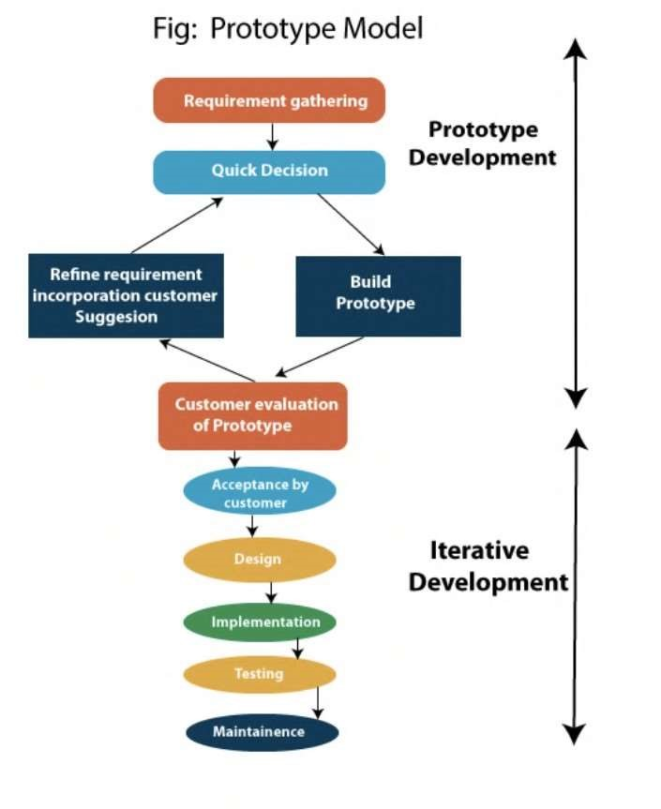

CHAPTER 5

SOFTWARE REQUIREMENT ANALYSIS

## 5.1 Introduction

To complete our project, we have used various open libraries and frameworks. Heart rate Monitor System is easy to use, all you need to do is, Open the interface, select the camera, lock the camera when exact forehead is detected, now image will be processed using the tool named OpenCV.

## 5.2 The Specific Requirements

Functional and Non-Functional requirements are given below.

The Functional Requirements:

* User Interface( UI ): Initially, the easy to use interface is required with the goal that client can undoubtedly deal with it and access the application. The interface should be very much planned and contained all the data. The catches should be at suitable spot. No module ought to get rowdy regarding specialized glitch.
* The Administrative functions: These are the capacity that goes under the control of organization or the board or the framework overseer goes under this, for example, an extra to the new data, actualizing these new modules or the capacities, by transferring of new archives, or by refreshing the substance to the site.
* Reporting Requirements: This is the situation when utilize found any bother during the advancement of the application. In view of these reports and analysis,

]

the head will address the issue which will add the improved idea of site

* The Authorization Levels: The system would be fully authorized so that not third party can change the system. That information should be relevant to the content and in case of any unwanted situation occurred thee admin should be reached immediately.

## Non-Functional Requirements

* Security: The data which is provided to user should be secured and it should not tend to look up the user data stored in the system. And it should not cause malwares to the user’s system. No third party should access the details provided by the users.

* Usability: This system should be intereactive and must have instinctive (UI) which make it outstandingly favorable to use. Every customer who have the key system meets the measures to get to the interface should be offered bit of leeway to get to it.
* Performance: The performance matter a lot weather its offline or online. If your system is running online then make sure the system can be operated on low internet speed. The performance can be accounted in terms of result. The system should tend to show the most accurate result in all the cases.

* Supportability: The interface should be able through whole the systems and multi operating system. Many times, we have seen websites not working across many systems. So, this should be avoiding so that all the users can access the services without any problem. It can help to visit through large and large audience.

* Reliability: System should be reliable to the user. Then it comes to the reliability lots of websites tries to track the activity of user by diving into their personal systems such activities should be denied so that user can access the services without any threat.

CHAPTER 6

DESIGN

## 6.1 System Design

We have tried to keep the design of the application very simple and easy to understand. The application can be easily run on any operating system as it is designed using python and we all know that python is platform independent. The camera is the main resource require by the web application for the image processing.

The responsibility of the team has been divided into the team. One makes sure that content displayed on the interface is relevant or not while the other works on the results received by the other member. More or less the work are the same. Both works to develop and enhance the usability of website using new modules to the site.

## Customer/User Profiles

Users of our applications can be anyone from kids, students, adults, elderly people, researchers etc., This application can be used anywhere by anyone without any prior knowledge. People in rural areas do not much awareness about using modern technology, our application is made to target all those types of users who aren’t aware. The doctors can even use it to find the heart rate of a person over the time. It will make it much easier for them to analyses the wellness of a person. Schools or colleges are using smart devices to teach the students. So, it can be helpful for them too. This can be the submodule of the application where it can be deployed in mobile application and enable the people to let them find their pulse rate over a time. This project is going to help all the aspirants and visitors’ users who want to keep themselves healthy.

6.2 Design Notations

* Use Case Model

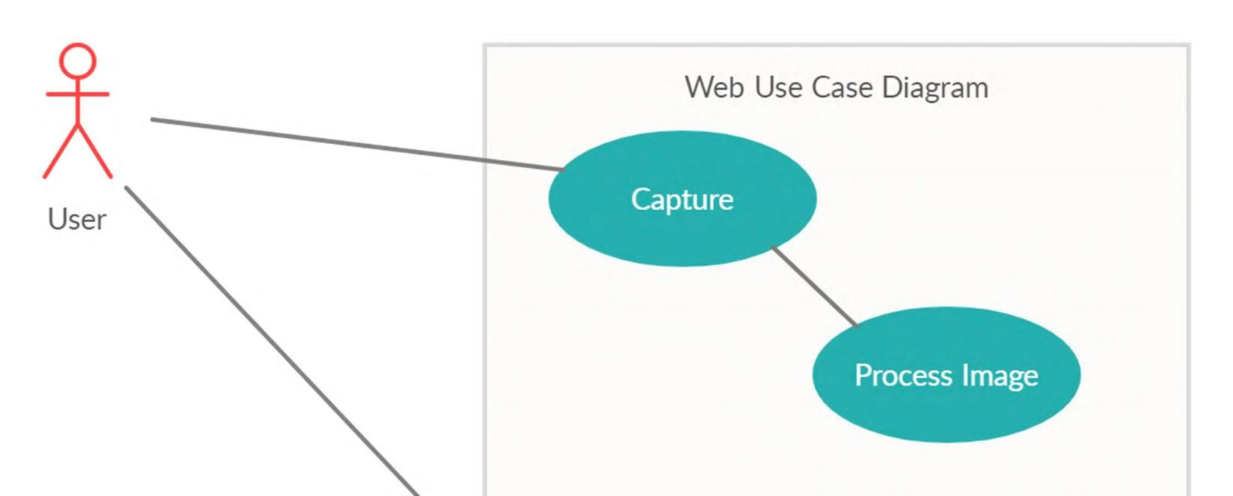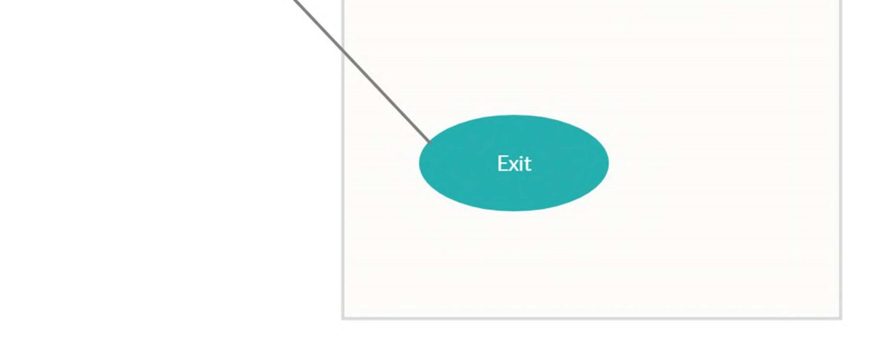

Figure: Webcam UCD

* E-R Diagram

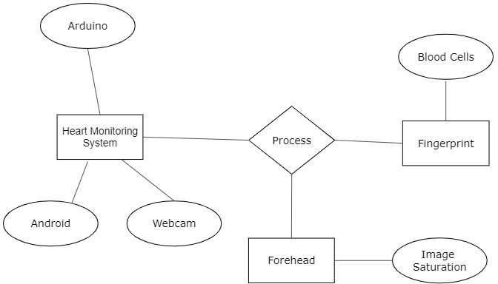

Figure 5: ER Diagram

## 6.3 Detailed Design

Design and analysis Plan of the Project has been planned into two classes. The initial segment is Machine Learning model and the other is GUI. For the advancement of Machine Learning model, we utilized python library OpenCV. To build up the model, we have utilized different open source library which help the improvement to be conceivable. Another part is GUI to build up that we utilized python. Aside from that to incorporate these two cooperates we have utilized EEL library in python which was the most imperative to coordinate the whole application as single unit.

6.4 Flowcharts ….incomplete

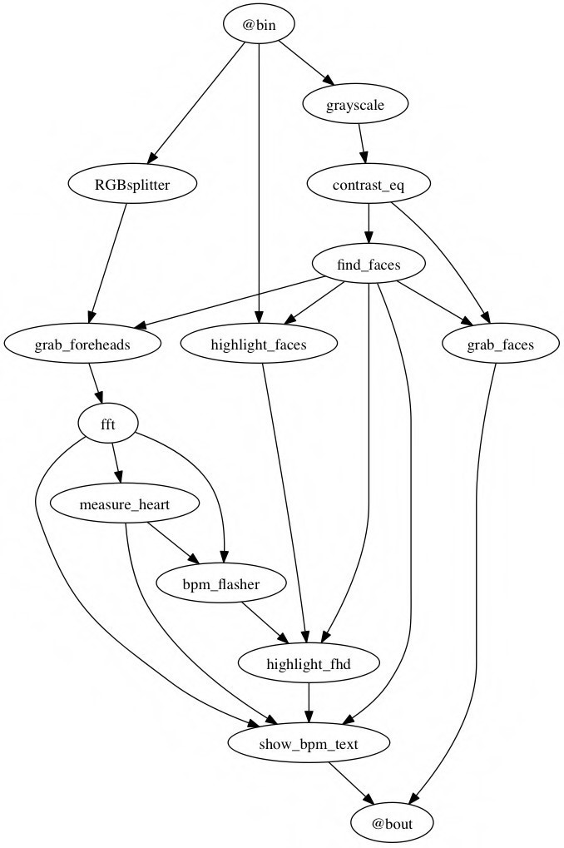

Webcam dataflow/Execution of the System.

CHAPTER 7

TESTING

We have precisely tested the application by taking the functionality and the application structure in mind. All the features were regularly checked during the development and after the development was over.

The application has been tested thoroughly and now ready to use.

## 7.1 Functional Testing

Functional testing is the sort of black box messaging where it doesn't make a difference that how you have composed the code. The sole of the utilitarian testing is check if the framework is functioning admirably. To assess the framework the framework is gone through barely any planned experiments. In the event that the framework finishes the assessment cases and the outcome overcome the objective so framework is announced well working.

Functional testing involved five steps:

* To identify the function of software which it supposed to be.
* The input is created on the bases of functions specification.
* To recognize the yield dependent on the capacity's particular.
* The execution of the experiments is observed
* The correlation is been the yield and anticipated qualities

## 7.2 Structural Testing

Structural testing is utilized to test the structure of the code not at all like practical testing where structure doesn't make a difference. Be that as it may, in Structural testing everything spins around the structure of the code. The Structural testing is likewise called as white box testing or can be clear box testing or additionally called as glass box testing or straightforward testing.

White-box testing, programming aptitudes and interior structure of the code are utilized to configuration experiments. The analyzer needs to pick commitments to find courses through the code and choose the appropriate yields.

White-box testing can be applied at different levels including the unit, joining and system levels of the item testing measure yet regularly done at the unit level. It can test ways inside a unit, ways between units during joining, and between subsystems during a system level test. It can assist with recognizing numerous blunders through the code.

## 7.3 Levels of Testing

In there four levels of testing which are

* Unit testing verifies weather each component of the software working well as individual or not
* Integration testing ensures weather all the units after combining working well or not to hit the target.
* It is the next level of testing where the software is tested as whole whether it works well or not.
* The final is the acceptance testing where green signal is given to launch the product is it passes all the criteria.

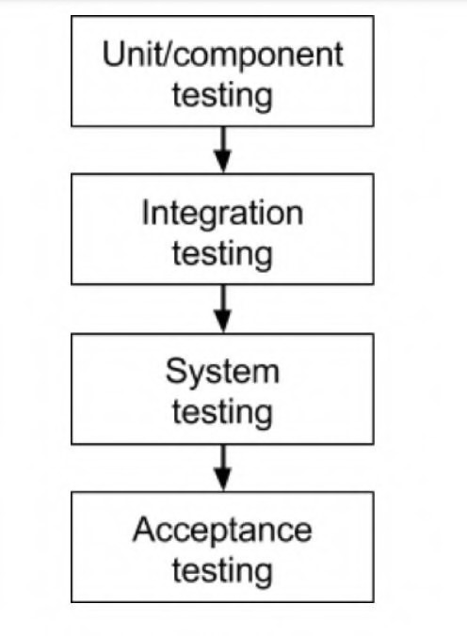

Figure 7: Diagram of Level of testing

## 7.4 Testing of Project

After the project work is completed, we tested it weather it works well it not. The results show the success has been marked across different test cases.

CHAPTER 8

IMPLEMENTATION

## 8.1 Implementation of a Project

To implement the project we have used several programming languages including Python, OpenCV, C, C++ etc. It's professionally categorized detailed below.

Programming:

1. 1. System Requirements- Windows 7/8, Mac OSX 10.6 and further, Linux, Ubuntu, Mint,Kali and so forth.

1. Python [v2.7-3.5] (As a programming language).

1. Open CV [v2+] (For face-detection & forehead region tracing; Applicaton of optical intensity).
2. Numpy and Scipy (For mathematical operators and calculation)

1. PSP (Pulse Sensor playground) Library [v1.5.1] (provides all the tools for pulse calculation)

## 8.2 Post-Implementation and Software Maintenance

Post Implementation:

We have implemented this applicaton for the convinience of health conscious people. For easier accessibility we have further plans to distribute the mobile app via play store and pc applicaton via github and source forge repository.

Software Maintenance:

Support is the last stage in the product advancement measure, as the program is created. A pattern of work appropriation has arisen and subsequently the measure of work and asset exhausted on programming upkeep is developing. In task improvement the support alone requires 60% of exertion.

Software maintenance can be classified into four types:

* Adaptive Maintenance
* Corrective Maintenance
* Preventive Maintenance
* Perfective Maintenance

Adaptive Maintenance is applied when changes in the outer climate make the need of alterations in the product. It manages adjusting the product to new climate.

Corrective Maintenance plans to address the mistakes that are revealed after the product is utilized. It manages fixing the bugs in code.

Perfective Maintenance joins upgrades that are mentioned by client network. It centers around refreshing the product as indicated by the client prerequisites.

Preventive Maintenance improves future practicality and unwavering quality of and gives an establishment to future upgrades. It centres around making the product more viable and refreshing the documentation. The undertakings performed during the product improvement measure characterize practicality and have a significant effect in the achievement of any support approach. Figuring out and Reengineering are the strategies needed to perform upkeep on the venture.

CHAPTER:9

LEGACY OF PROJECT

## 9.1 Current Status/Task Condition of the Project

We have implemented this project initially on the basic idea kept in mind that our application should perform multiple features including heart rate monitoring and bpm measurement. After investing several weeks in this project, we have come up with a prototype/product which meets industry standards, performs all features discussed and is accepted globally. The current status is the project is functionally sound and runs smoothly. The errors are reduced and mitigated and has been more responsive as compared to previous versions.

## 9.2 Remaining Areas of Concern

We as a team are working on further development of this project which includes the application and website availability 24/7 and minor bug fixes. Also, multiple functionalities are determined planned to be added in current version for better client experience. Efforts are made to implement more user-friendly ness by providing weekly health subscriptions and setting timely reminders.

9.3 Managerial And Technical Lessons Learnt

Technically we came to know about so many libraries which we used to make the project including NumPy, pandas, TensorFlow etc. We also come to know about how to connect the Machine Learning model with User interface. In managerial lesson, we learnt about how to manage the large project by dividing them into small modules and about time management, how much time we should assign to the modules according to their priority.

CHAPTER 10

USER MANUAL

Desktop app is easy to use and very interactive. The user manual to use desktop app is as follows:

For Webcam Pulse Detector: We are using an inbuilt webcam, in order to test the application, device is placed in a way that non-contact surface of human body is captured for few seconds. The normal distance required in between the device and the human body can be around 100 cm. An ambient IR green light will be formed on the forehead of the human body. Here person is tested in the presence of natural light in the room with all equipment’s positioned correctly. During contraction and expansion of cardiovascular events, there will be changes in the facial blood vessels below the skin which further lead to change in the path length of reflected ambient green light. These facial volumetric changes are recorded by the webcam and processed using RGB color pick up sensor with all fluctuations recorded during the event.

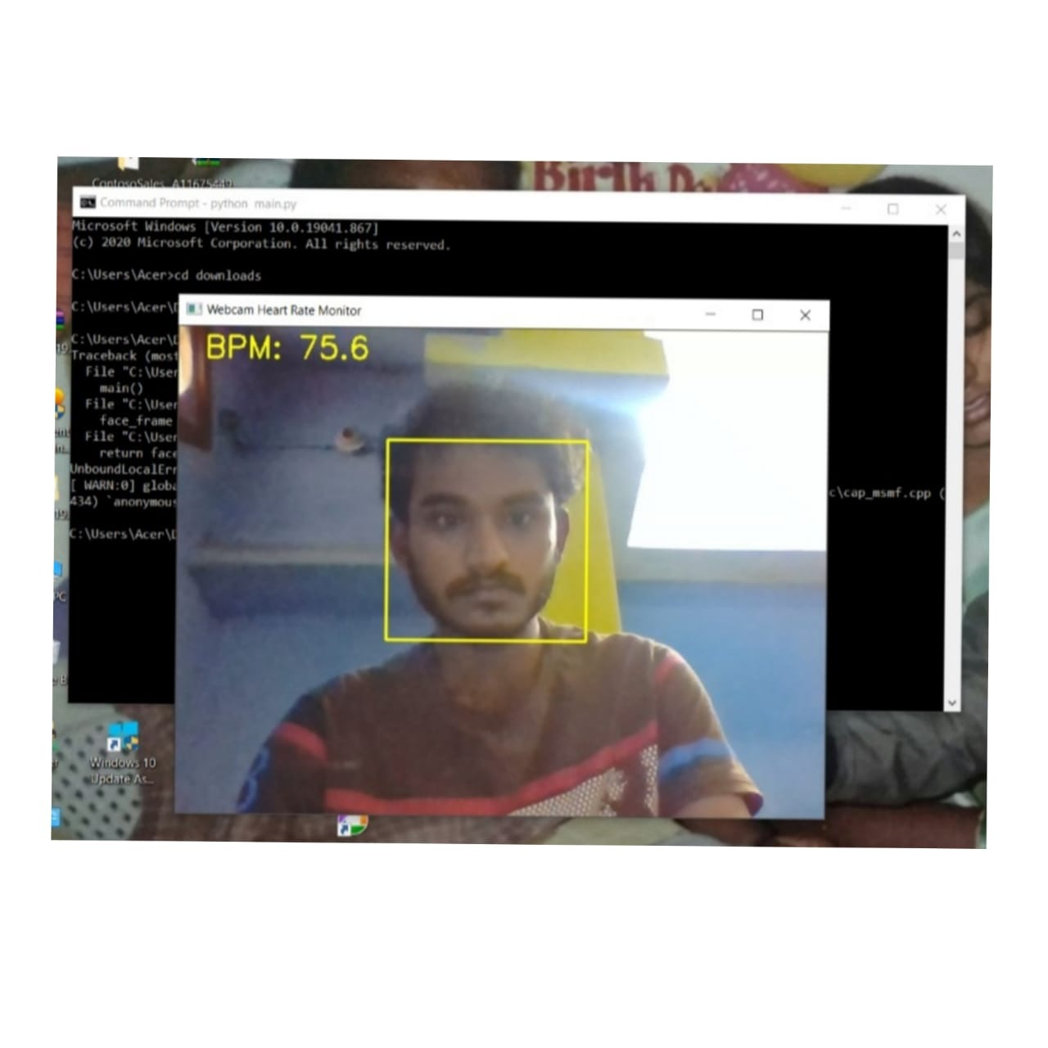

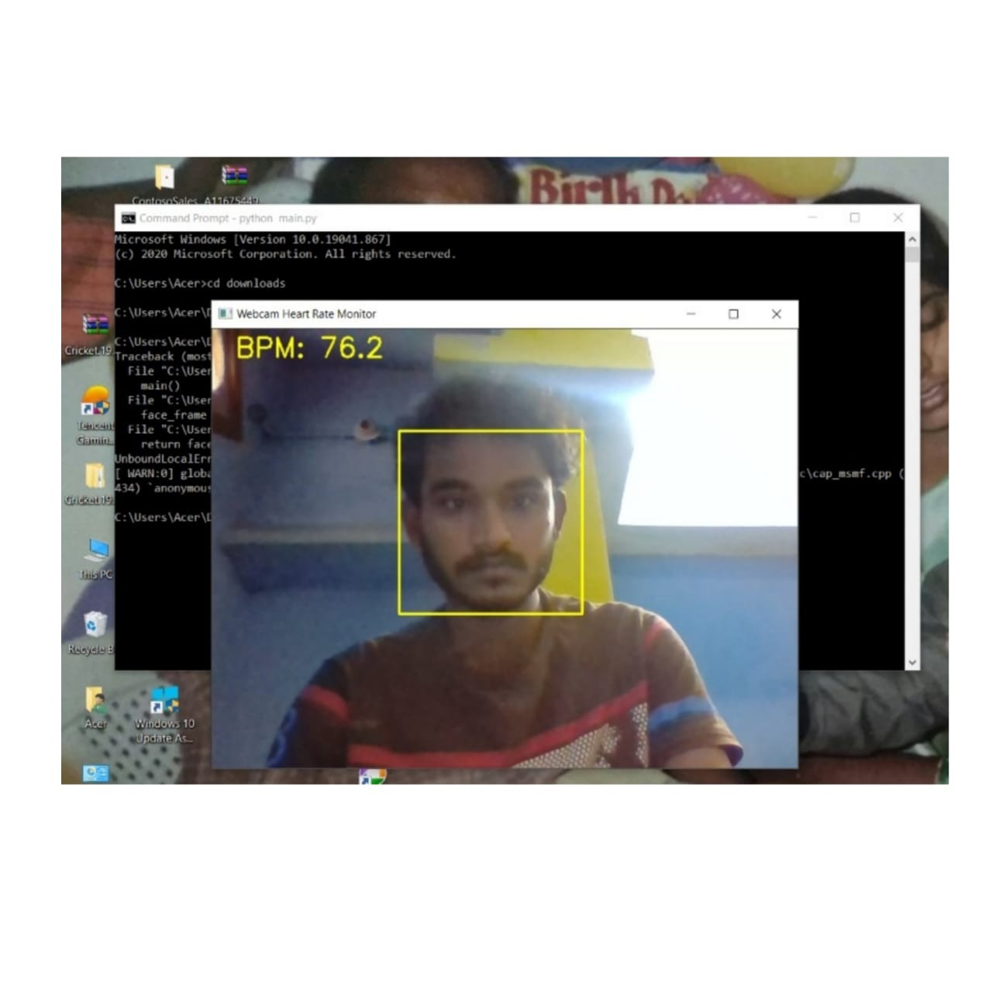

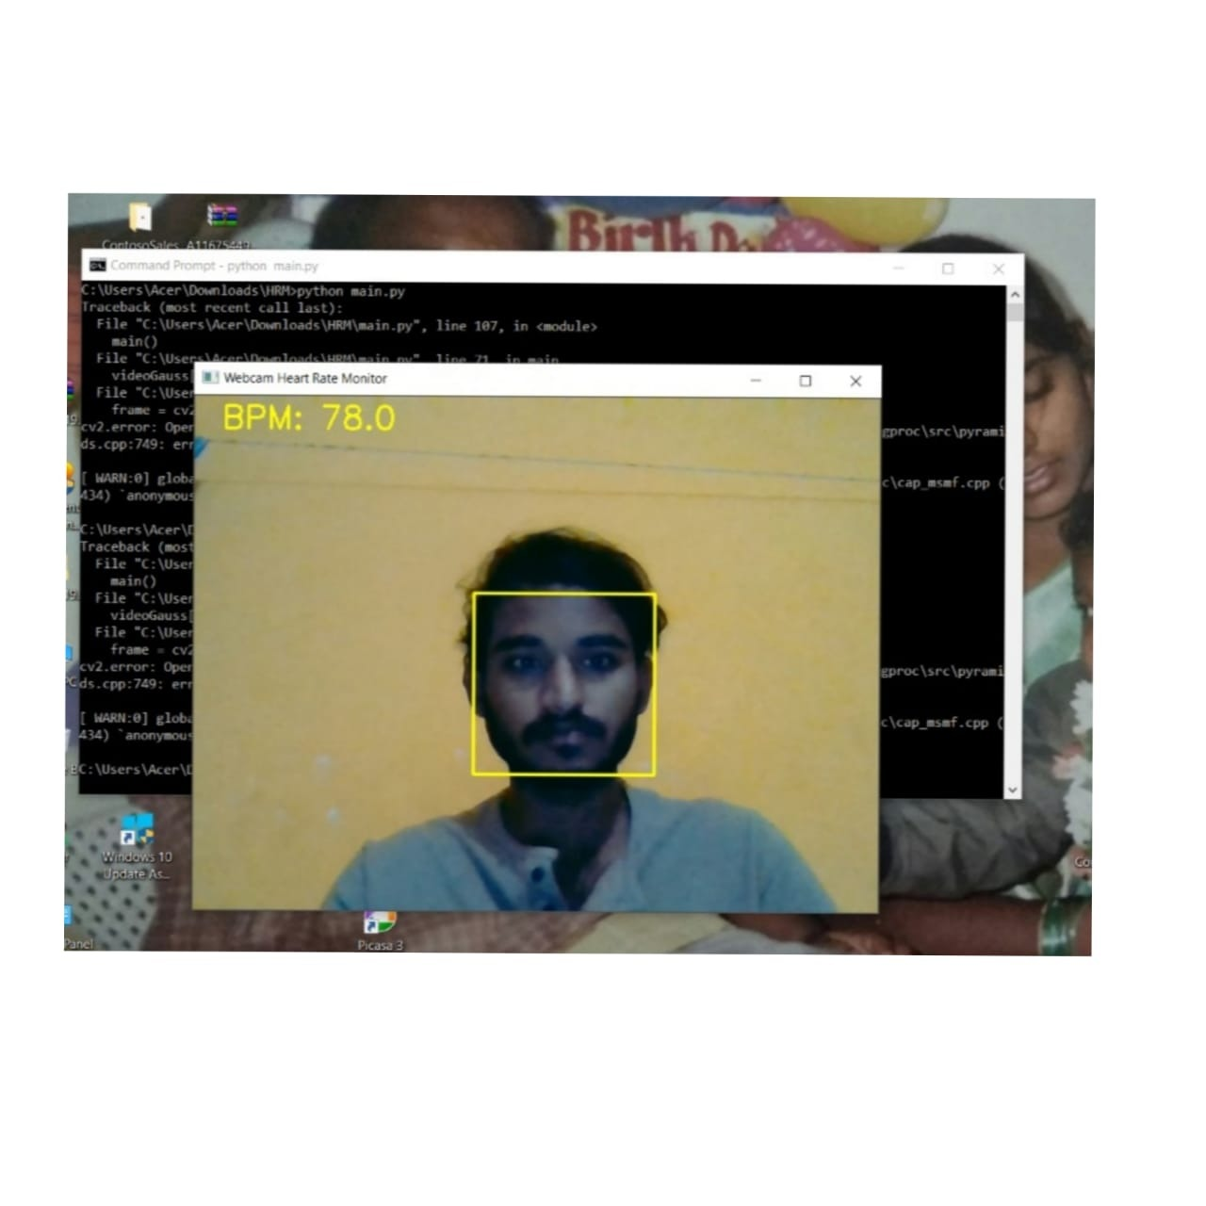

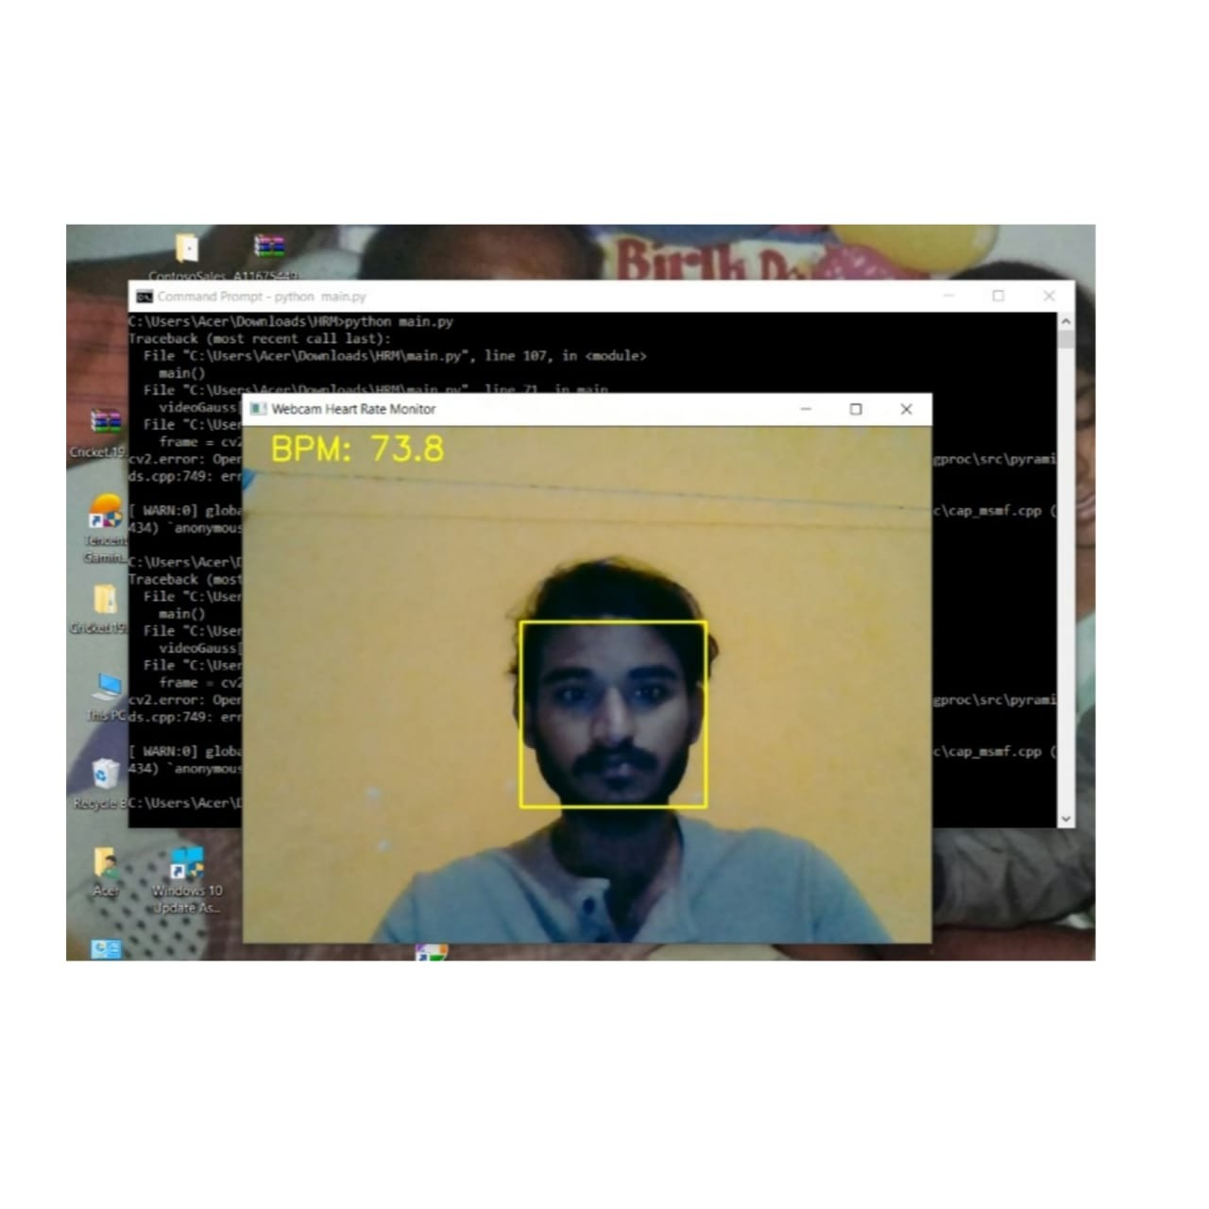

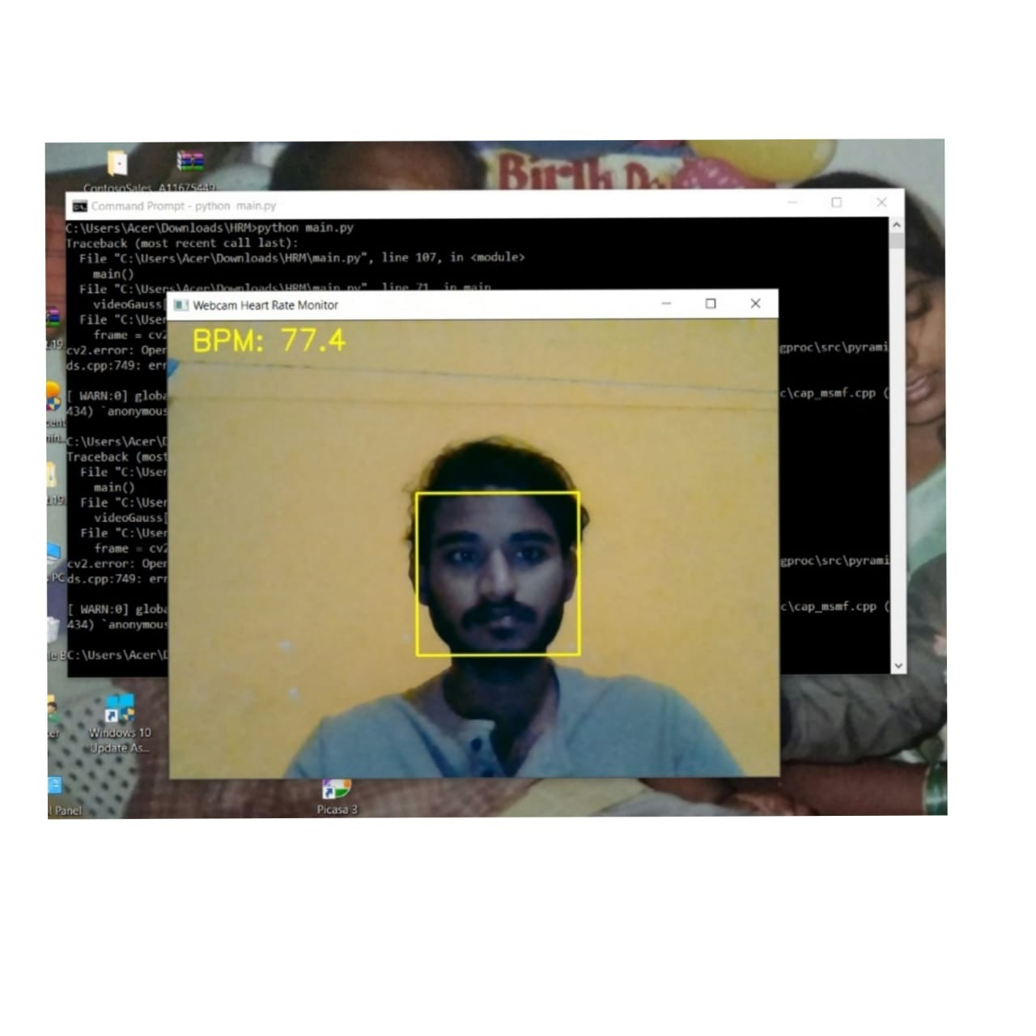

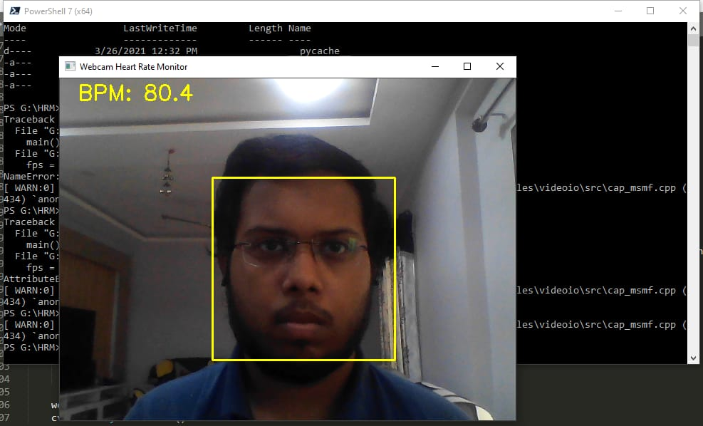

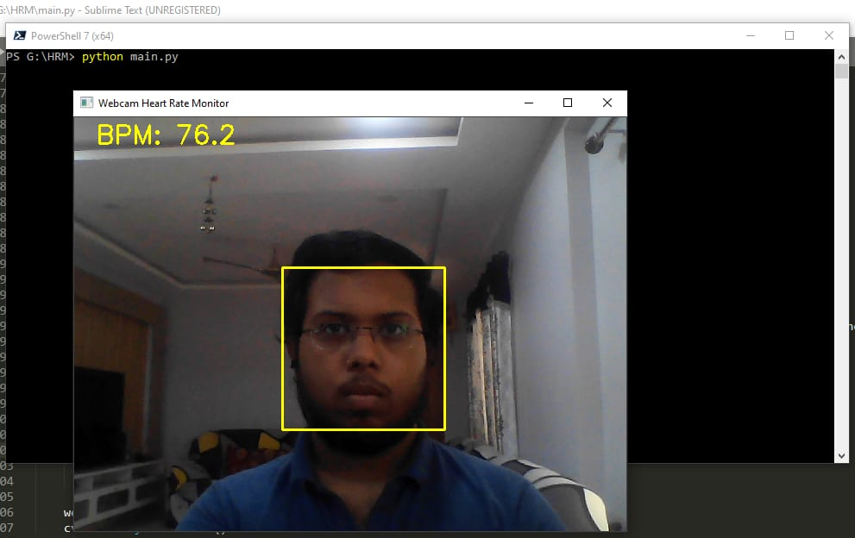

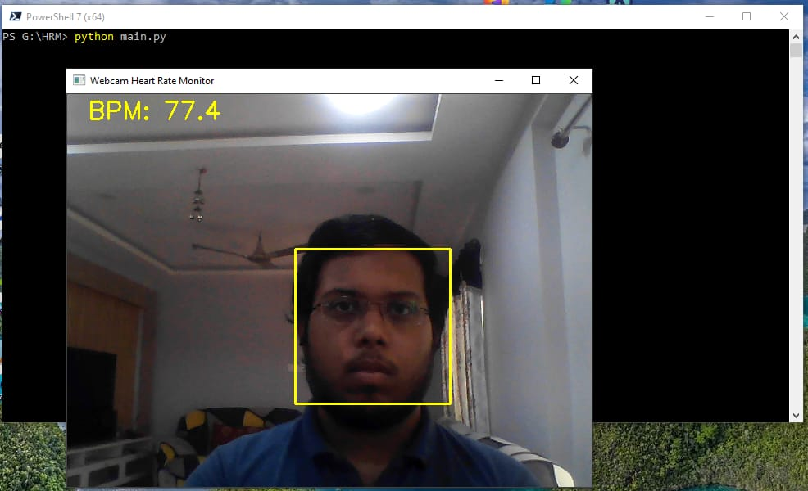

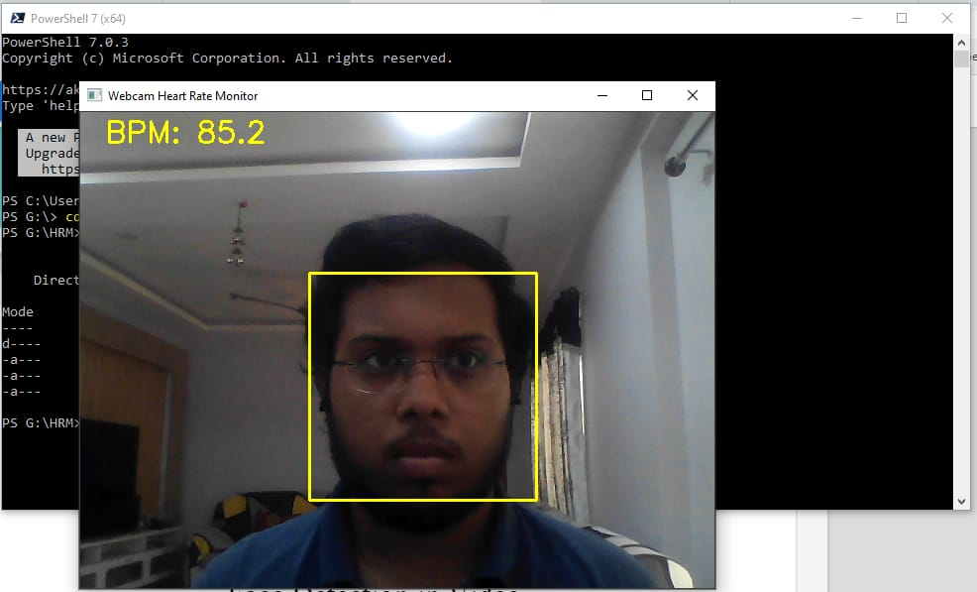

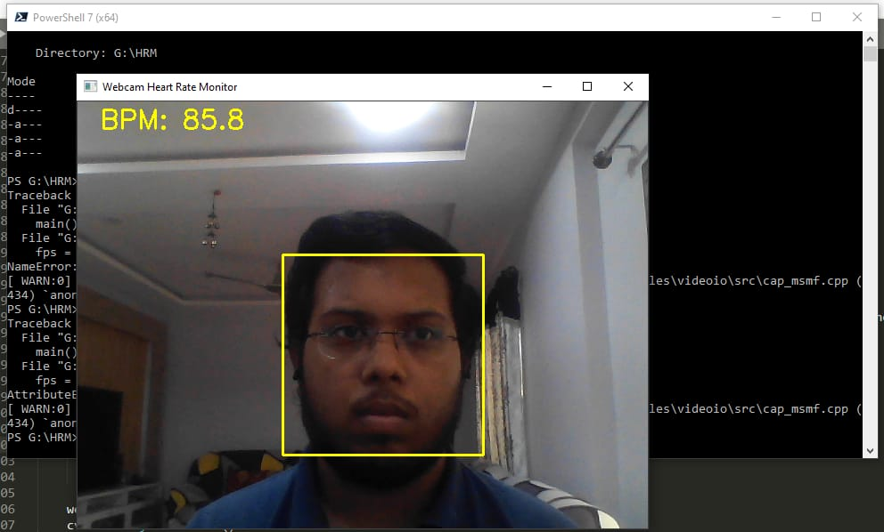

CHAPTER 11

SYSTEM SNAPSHOTS/ SOURCE CODE

This section contains the source code of some important functionalities of Desktop app (Webcam Pulse Detector).

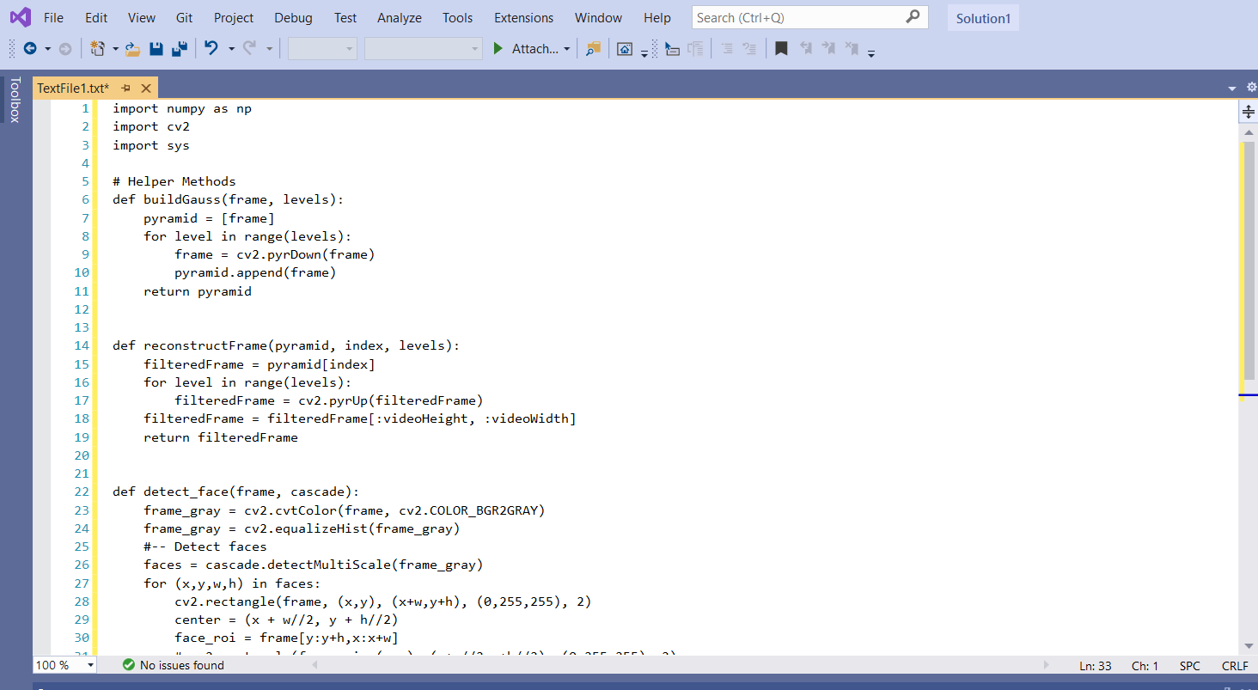

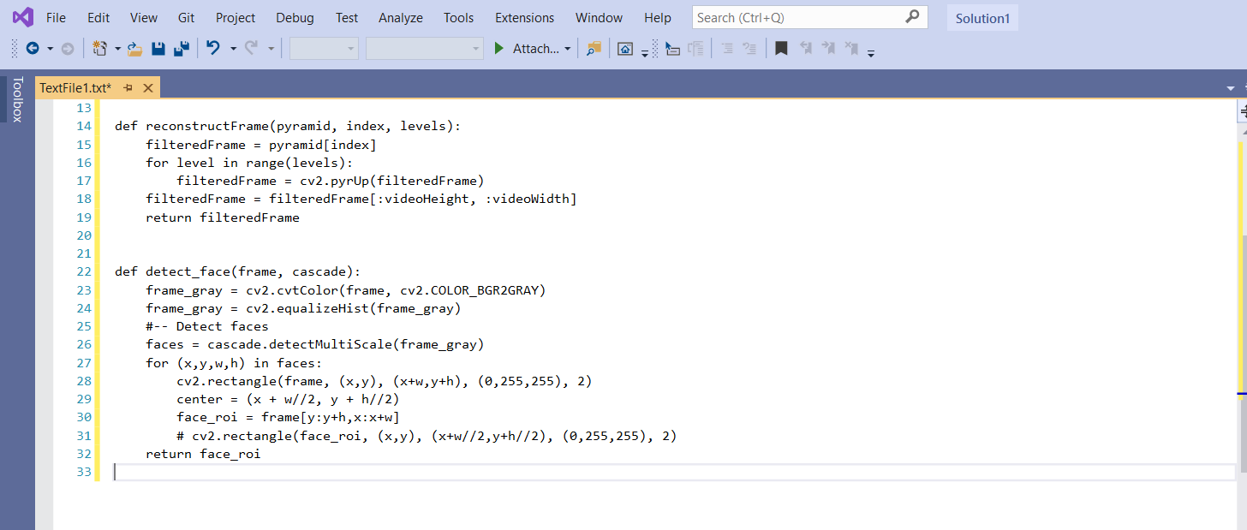 Figure: Source code snapshot

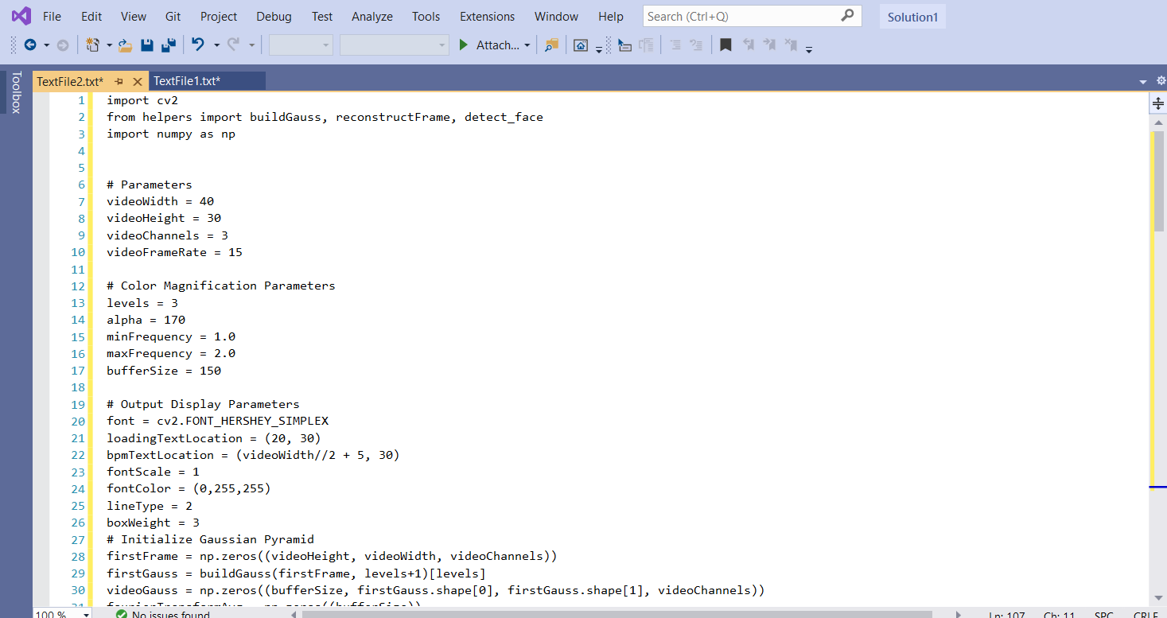

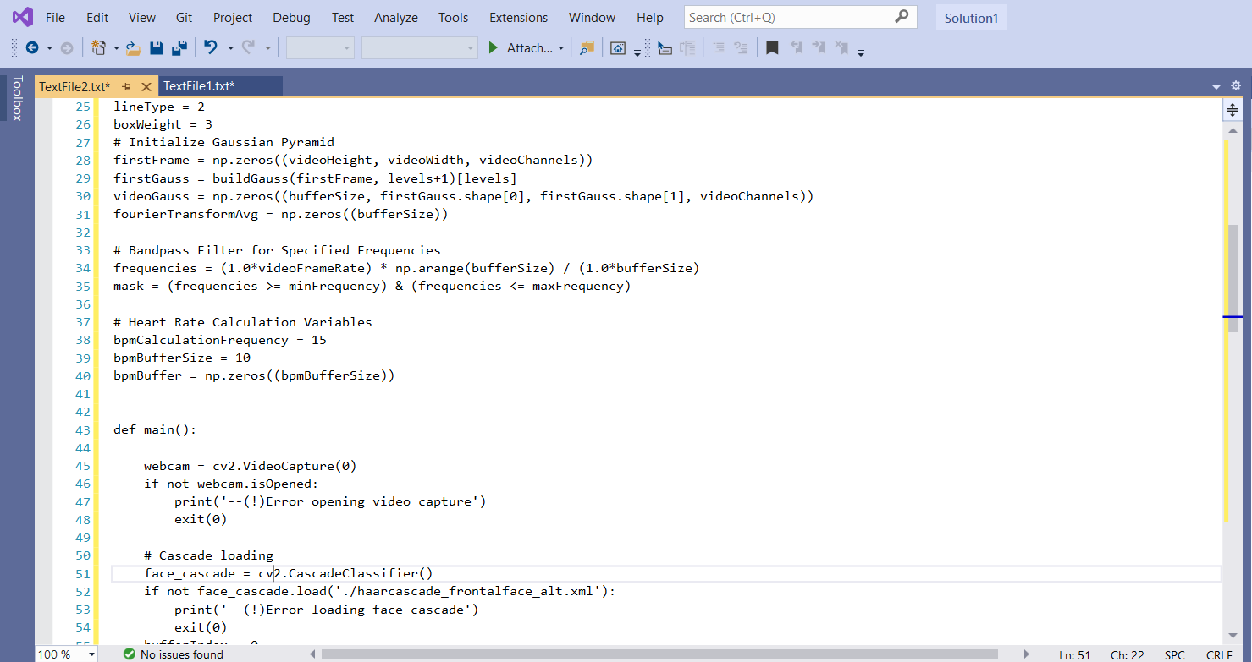

Figure: Source code snapshot

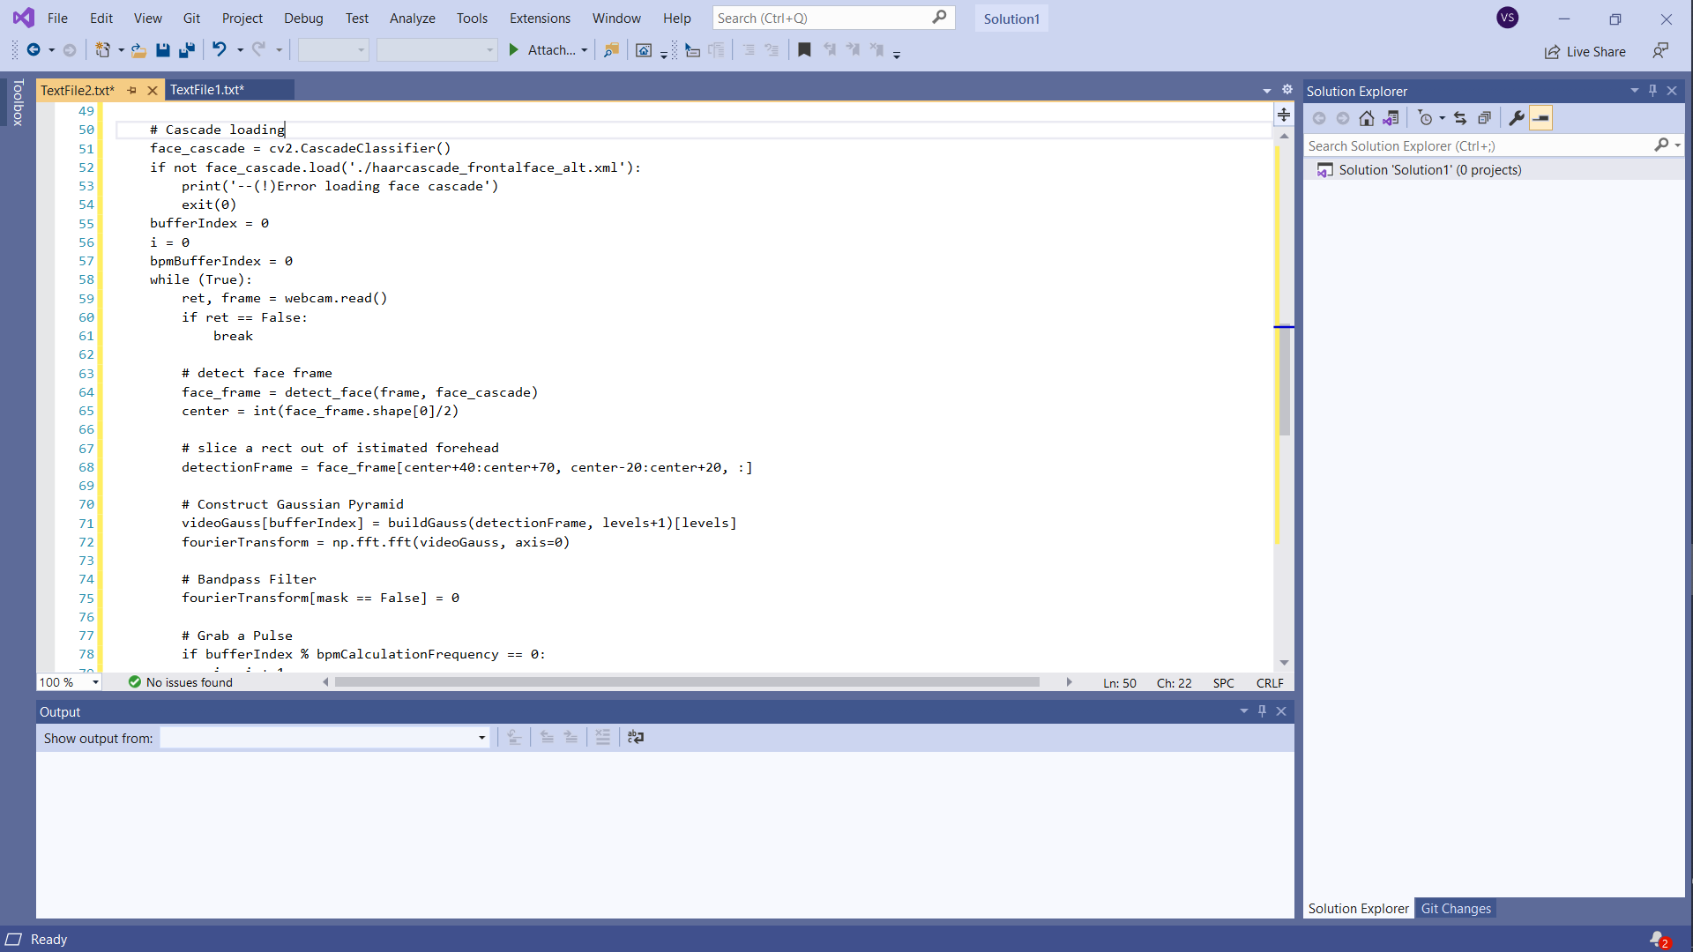

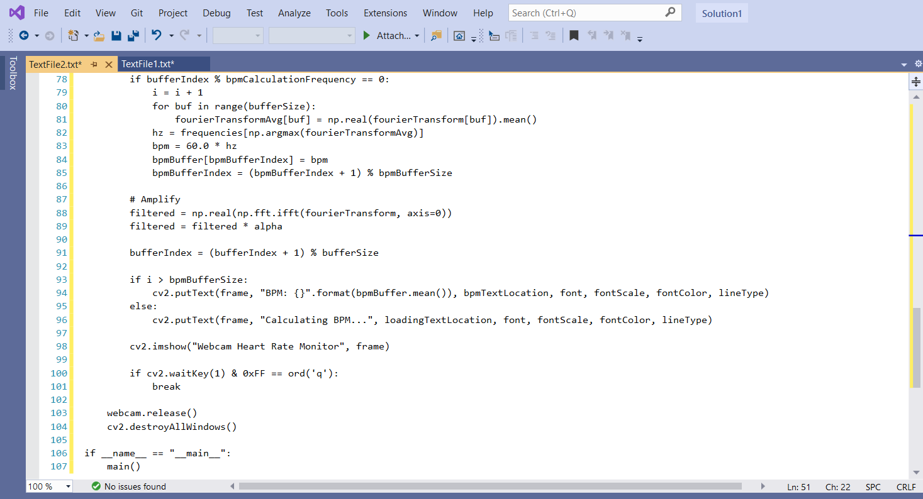

CHAPTER 12

BIBLIOGRAPHY

https://www.researchgate.net/publication/268685179_Measuring_the_pulse_rate_by_using_webcam

https://pypi.org/project/heartwave/ https://lifehacker.com/the-webcam-pulse-detector-shows-your-life-signs-using- y-1704207849 https://en.wikipedia.org./wiki/Heart_rate_monitor https://en.wikipedia.org./wiki/Heart_rate

https://www.researchgate.net/publication/330652528_Real-

Time_Heart_Pulse_Monitoring_Technique_Using_Wireless_Sensor_Network_and_Mobile_ Application http://ijsetr.org/wp-content/uploads/2016/01/IJSETR-VOL-5-ISSUE-1-84-89.pdf https://www.postscapes.com/bluetooth-heart-rate-monitor/ https://www.pinterest.com/pin/504755070720245302/